Assignment #2: Advanced CSS and JavaScript

There are two projects in this assignment. Follow the instructions for each project to complete it. You have been provided with the necessary files to complete the projects.

Some websites that you might find helpful in completing this assignment are:

1. <https://getbootstrap.com/> (to download the latest version of Bootstrap)
2. <https://www.w3schools.com/bootstrap5/> , <https://www.w3schools.com/bootstrap5/bootstrap_get_started.php> (bootstrap 5 tutorial)

**Project 1: Share Your Travel Photos (Bootstrap)**

# Overview

You may use the **Bootstrap CSS framework** (included with the start files). Alternatively, you may prefer to download the most recent version as well as modify chapter07-project03.css and chapter07-project03.html so the resulting webpage looks similar to that shown in Figure 1.

# Instructions

1. Examine chapter07-project03.html in the browser. You will need to add a fair bit of HTML in accordance with the Bootstrap documentation. Since you can use the various Bootstrap classes, you will need to write very little CSS (the solution shown in Figure 1 has just over a dozen rules defined).
2. The first step will be defining the basic structure. Figure 1 shows that most of the content is contained within a main row (i.e., below the navbar and above the footer) that is composed of two columns (one with a width of 2, the other with a width of 10). The Bootstrap grid classes (e.g., col-md-10) are shown at the top of the figure. One of the columns has a nested row within it that contains the main photo image and the data on the photo.
3. The footer contains three columns. One of these contains another nested row.
4. Figure 1 identifies the other Bootstrap components that are used in this project. You will need to use the online Bootstrap documentation for more information on how to use these components.

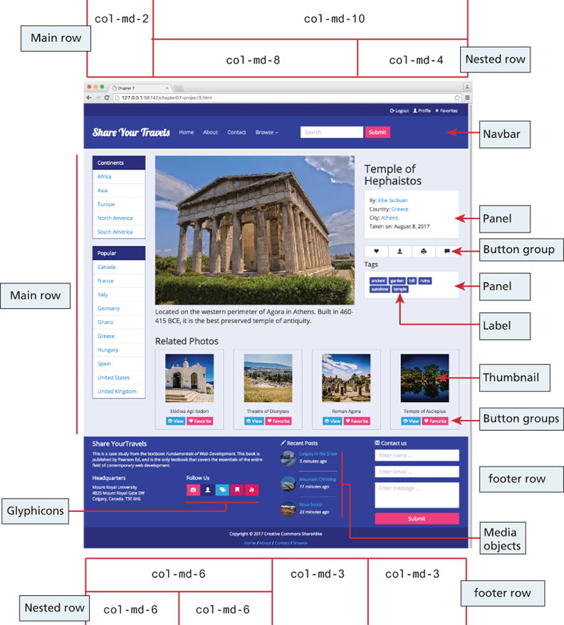

Figure 1 Completed Project 1

# Testing

1. Be sure to test by increasing/decreasing the size of the browser window. If you shrink the browser window sufficiently it should use the built-in Bootstrap media queries to adapt nicely to the smaller window size.

**Project 2: Share Your ­Travel Photos (JavaScript 2)**

# Overview

This project provides the opportunity for you to demonstrate your ability to use JavaScript to update the DOM and to handle events using both event delegation and “regular” event handling.

# Instructions

1. Examine chapter09-project02.html. You will need to add event handlers to the thumbnail images and to the larger image. You will **not** however need to make any changes to the provided markup or CSS.
2. All of your event handlers must execute only after the page has loaded.
3. You are going to **add a click event handler** to each of the thumbnail images. When the smaller image is clicked, your code will show the **larger version** of the image in the <img> element within the <figure> element. This same event handler will also set the <figcaption> text of the <figure> to the clicked thumbnail image's title attribute. Your event handler must use event delegation (i.e., the click event handler will be attached to the <div id=“thumbnails”> element and not to the individual <img> elements).
4. You must also **add event handlers** to the **mouseover** and **mouseout** events of the <figure> element. When the user moves the mouse over the larger image, then you will fade the <figcaption> element to about 80% opacity (its initial CSS opacity is 0% or transparent/invisible). When the user moves the mouse out of the figure, then fade the <figcaption> back to 0% opacity. You can set the opacity of an element in JavaScript by setting its style .opacity property.
5. You can **animate** (for instance, a fade is an animation) any CSS setting (such as opacity) in JavaScript by setting its **style.transition** property. For instance, in JavaScript, setting an object's transition style property to “opacity 1s” tells the browser to transition the opacity to its next setting across one second.

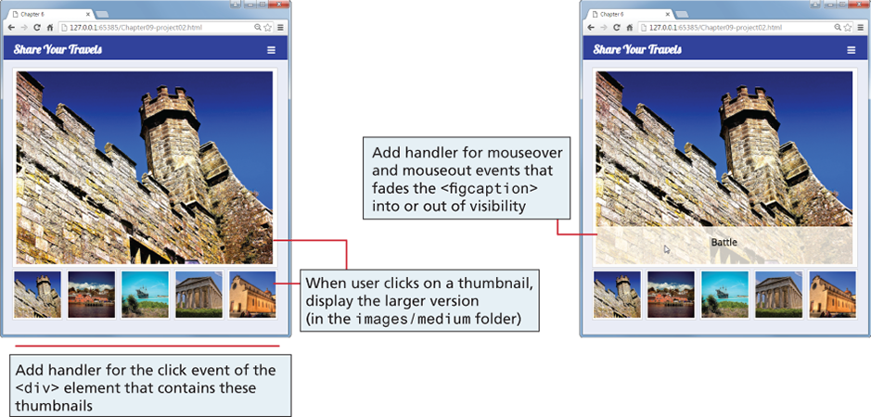

Figure 2 Completed Project 2

# Test

1. Verify that the page changes the larger image when you click on a thumbnail. Hover the mouse over the large image to verify that the caption fades into visibility, and that it fades to invisibility when the mouse moves out of the image (see Figure 2).

**Assignment Submission**

Rename the assignment folder containing all your assignment 2 files as follows: assign2_*initialLastname* (e.g., *assign2_jsmith*). Zip your assignment 2 folder and upload the zipped file to Moodle before the due date / time.